In SSIS (Sql server integration services) we can copy the content of a folder from one location to another location by using **File System Task**.

Suppose we have SSIS folder at C:\SSIS which have many folders and files. We want to move the content of SSIS folder to other location i.e. at C:\Destination\

Step 1:  Create a new integration services project.

Step 2: In control flow tab drag and drop the File System Task.

[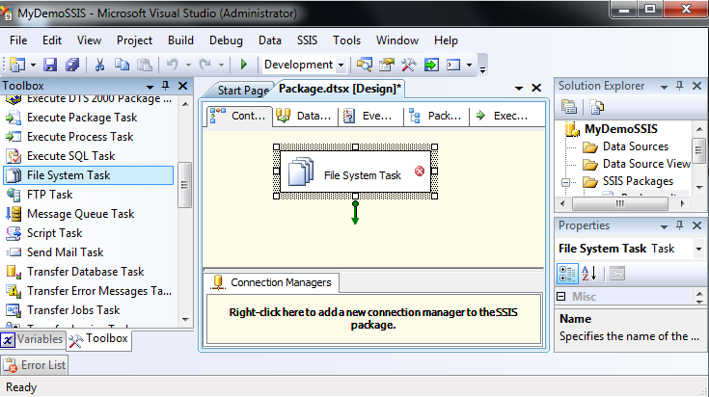](http://3.bp.blogspot.com/-R61jTHS2j7A/Tr5rMnEhM-I/AAAAAAAABdQ/cQkUacAEZmY/s1600/fs1.png)

Step 3:  Double click on File System Task. We will get the File System Task Editor.

**Name**:  It can be any name of task. In this example task name is *Move folder*.

**Description**: It is description of the task. In this example description *is Moving the SSIS folder to Destination folder.*

**Operation**:  There are ten different operations performed by File System task. They are:

|  |  |
| --- | --- |
| Task Name | Use |
| Create directory | To create a new folder at given path. |
| Delete directory | To delete an existing folder. |
| Delete directory content | To delete the all content of a folder. |
| Move directory | To move a folder from one location to other. |
| Copy directory | To copy a folder from one location to other. |
| Copy file | To copy a file from one location to other. |
| Move file | To move a file from one location to other. |
| Rename file | To rename a given file. |
| Set Attributes | To set the four attributes of a specific a file or folder. Attributes are:    1. Hidden    2. Read only    3. Archive    4. System |

In this example we have to copy a folder from one location to other so operation name will be *Copy directory*.

[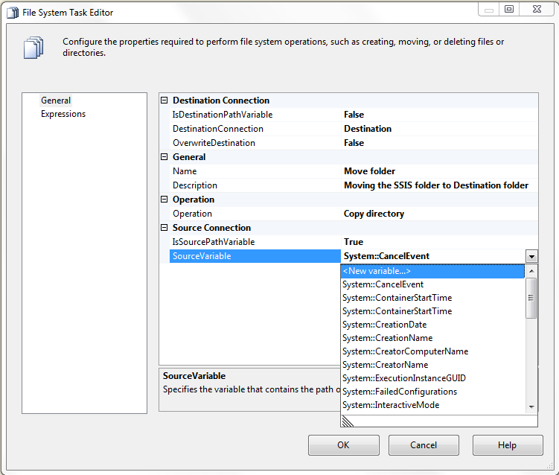](http://4.bp.blogspot.com/-Iq8hfFWgdxU/Tr5rPJsPkkI/AAAAAAAABdg/T27GQLZUSD8/s1600/fs3.png)

**IsSorcePathVariable**: It can be either true or false. If it is true then path of the source folder will stored in a variable. If it is false then path of the source folder will be static.

In this example we will go for both the options.

Option 1: Set the IsSorcePathVariable to true.

**Source variable**: To specify path of the source folder which we have to copy. Select <New Variable…> from combo box. We will get the Add variable window.

**Container**: To specify the scope of the variable. In this example we will use Package. It means scope of the variable is whole the package.

**Name**: Any name of the variable. In this example name of the variable is *SourceFolderPath.*

**NameSpace**: It can be either User of System. User means user defined variable. We can write any name of namespace of user defined variable. In this example we will keep *User.*

**Value Type**: Data type of variable. Since we have to store path of a folder so, we will choose String.

**Value**: It keeps the any value of a variable. In this example it will path of the source folder i.e. C:\SSIS

[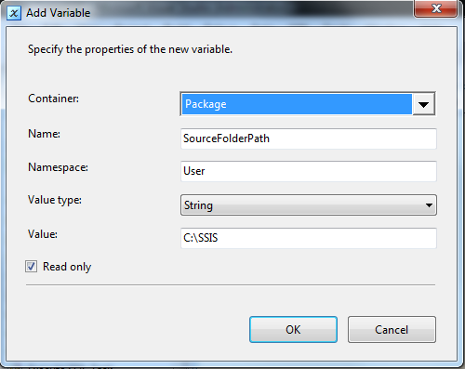](http://2.bp.blogspot.com/-Chr4I6ZPXfc/Tr5rN-46pyI/AAAAAAAABdY/Kc2vaxV_jvk/s1600/fs2.png)

Now click on OK button.

Option 2: Set the IsSorcePathVariable to false.

**SourceConnection**: To specify the path of the source folder. Choose the <New connection…> from combo box. We will get File Connection Manager Editor.

**Usage type**: In this example choose the Existing folder.

**Folder**: By clicking Browse button to choose the source folder path which has to copy.

[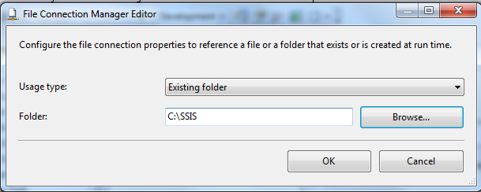](http://3.bp.blogspot.com/-haFHaAp0uAI/Tr5rQS01nZI/AAAAAAAABdo/PrzAcUqAB5Q/s1600/fs4.png)

Now click on OK button.

**IsDestinationPathVariable**: It can be either true or false. If it is true then path of the source folder will stored in a variable. If it is false then path of the source folder will be static.  Same way as we have done in case of source folder. In this example we will set to False.

**DestinationConnection**: Choose the destination folder path where we have to copy the folder. In this example it is c:\Destination

**OverwriteDestination**: It can be either true or false. If it is true then while copying it will overwrite if the files and folders of source folder are already present in the destination folder if it is false then it will be not been overwritten. In this example we will keep True.

[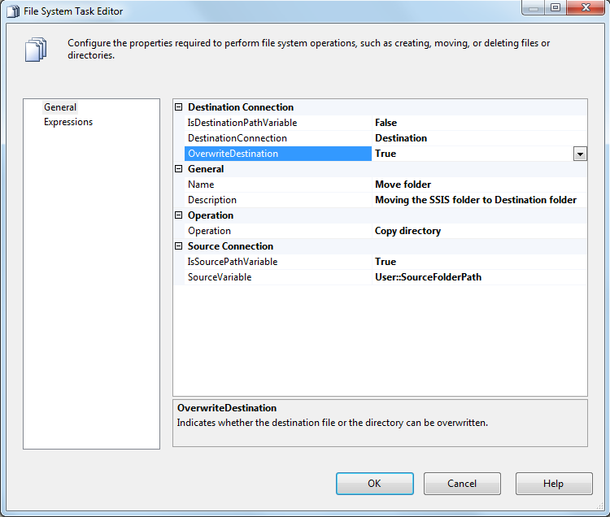](http://2.bp.blogspot.com/-QjXGMErWWa0/Tr5rRmG8YWI/AAAAAAAABdw/n0g4jkao8Pw/s1600/fs5.png)

Now click on OK button.

And run the application